
TECHAGENT
Independent AI Aggregator
Whitepaper
Token: TechCoinAgent (TCA)
Network: Base (ERC-20)
Version: 1.0 · June 2026
Slogan: Navigate the AI Economy
Website: techagent.com

Disclaimer
This document is provided for informational purposes only and does not constitute investment advice, a public offering, or a solicitation. TCA is a utility token granting access to features of the TECHAGENT platform; it is not a security and does not represent equity, shares, or any promise of profit. Cryptocurrencies are volatile and participation carries risk up to total loss of funds. All figures in this document are preliminary and subject to change. Nothing herein is a guarantee of future performance.

Executive Summary
TECHAGENT is an independent aggregator of the AI ecosystem — models, tools, AI agents, companies, influencers, benchmarks and real-world use cases in one place. As the AI market explodes, users drown in options, businesses struggle to evaluate real ROI, and AI vendors face rising acquisition costs and a trust deficit. TECHAGENT removes these inefficiencies by letting people discover, compare and adopt AI solutions based on outcomes rather than hype.
TCA (TechCoinAgent) is the utility token that connects the Web2 convenience of the platform with Web3 mechanics: access to premium features, payment for AI agents and workflows, staking for discounts, community rewards, and governance. The token is deployed on Base as an ERC-20 with a fixed total supply of 1,000,000,000 TCA.

1. Project Overview
TECHAGENT is a unified platform that aggregates the fragmented AI landscape and provides a single, trustworthy entry point into the world of artificial intelligence. Instead of building another isolated tool, TECHAGENT acts as connective infrastructure for the entire AI ecosystem.
Our mission:
While we still spark desire, can evaluate outcomes and the realization of ideas — let us help one another navigate the new, exciting and highly competitive world of artificial intelligence.
The platform serves three audiences in sequence: mass adoption via B2C, monetization via SMB, and scale via B2B / API.

2. The Problem

2.1. AI market fragmentation
The number of AI tools grows faster than anyone can track. Every week brings new models and services; choices increase while the ability to evaluate them objectively decreases.
This creates concrete pain points:
- High cost of searching for the right AI solution
- Lack of objective comparison
- No reliable trust signals
- Difficulty estimating ROI for business
- Fragmented information for users
- Rising customer-acquisition costs for AI vendors

2.2. Lost value
Without a neutral aggregation layer, users overpay or pick the wrong tools, businesses waste budgets on trial-and-error, and vendors burn marketing spend reaching the wrong audience.

3. The Solution: TECHAGENT
TECHAGENT combines several layers into one product:
- A catalog of AI services with use-case filtering
- A comparison engine across quality, cost and outcomes
- An AI agents marketplace (pre-built workflows & automations)
- A community reputation system focused on results, not marketing
- A B2B / API layer for enterprise routing and orchestration
- An aligned utility & incentive token (TCA)
Reputation is outcome-based: reviews evaluate not only features but the practical result, with anti-abuse safeguards and curator incentives that keep data accurate.

4. Market & Use Cases

B2C
Creators, freelancers, students and consumers discovering and comparing AI tools.

SMB
Small and medium businesses adopting AI for marketing, support, sales enablement and operations.

B2B / API
Enterprises consuming aggregated catalog data, orchestration APIs, white-label modules and AI routing.
Use Case 1: A user describes a task; the platform recommends ranked AI tools by real outcomes and price, and TCA unlocks premium comparisons and expanded access.
Use Case 2: A company launches AI agents through TECHAGENT to automate workflows and route tasks across multiple models.
Use Case 3: An AI vendor lists a product, receives qualified leads, and gains outcome-based reputation signals.

5. Technical Architecture

5.1. Layers
- Web2 platform core — catalog, search, recommendations
- Web3 utility layer — payments, staking, rewards treasury, governance
- AI orchestration layer — routing and workflow execution

5.2. Why Base
TCA is deployed as an ERC-20 token on Base, chosen for low fees, Ethereum-grade security, fast finality, simple onboarding and strong support for consumer-oriented applications. Multichain expansion is planned later.

5.3. On-chain components
- TCA Token Contract
- Vesting Contracts
- Staking Contract
- Rewards Distribution Contract
- Governance Module
- Multisig Treasury wallets

5.4. Security
- Independent smart-contract audits before TGE
- Multisig-controlled treasury
- Role-based access control
- Anti-abuse logic for rewards & reviews
- Bug bounty program

6. Token Utility & Tokenomics

6.1. Token parameters
Parameter | Value
Token name | TechCoinAgent
Ticker | TCA
Standard | ERC-20
Network | Base
Decimals | 18
Total supply | 1,000,000,000 TCA
Contract | 0x0F81294C2549D1CabAc3ecBbd0d21e2d073F2309

6.2. Utility
- Platform Access: Pay for premium features and expanded access across TECHAGENT.
- AI Agents & Workflows: Pay to run AI agents and automation templates from the marketplace.
- Staking: Stake TCA for discounts and expanded service access.
- Governance: Vote on platform development and ecosystem parameters.
- Community Rewards: Earn for reviews, data contributions and catalog curation.
- Review Curators: Incentives for maintaining data quality and accuracy.
- B2B / API: Access to enterprise programs, routing and API integrations.

6.3. Token allocation
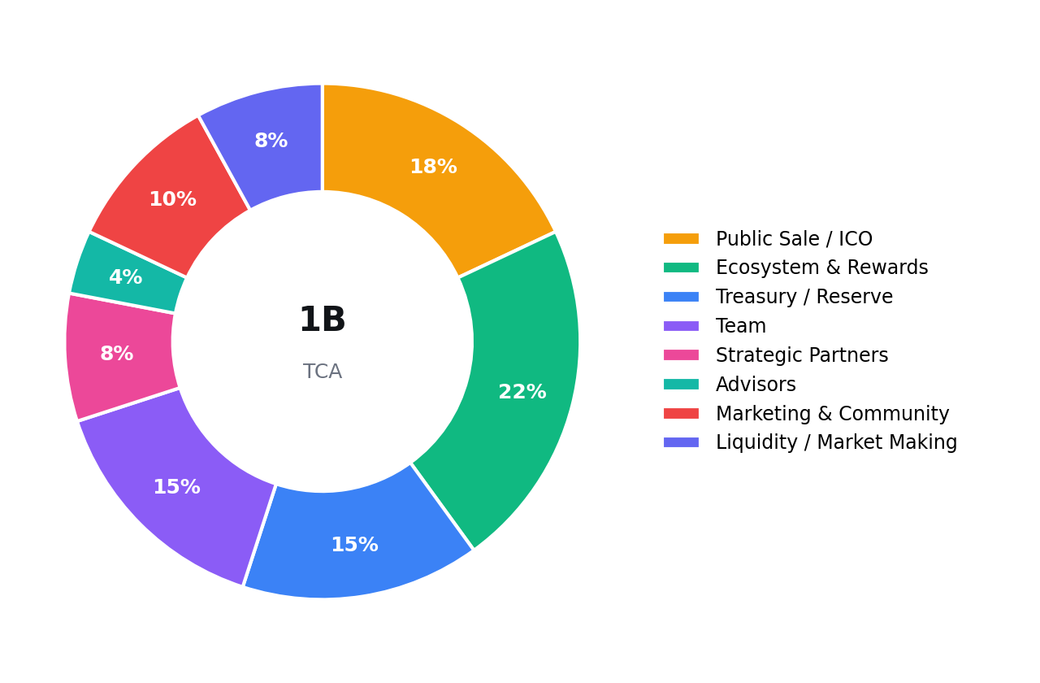
Category | Share | Tokens
Public Sale / ICO | 18% | 180,000,000
Ecosystem & Rewards | 22% | 220,000,000
Treasury / Reserve | 15% | 150,000,000
Team | 15% | 150,000,000
Strategic Partners | 8% | 80,000,000
Advisors | 4% | 40,000,000
Marketing & Community | 10% | 100,000,000
Liquidity / Market Making | 8% | 80,000,000

6.4. Vesting schedule
Category | At TGE | Cliff | Unlock
Public Sale | 20% | — | Linear over 6 months
Team | 0% | 12 months | Linear over 24 months
Advisors | 0% | 6 months | Linear over 12 months
Strategic Partners | 0% | 3 months | Linear over 12 months
Marketing & Community | Partial | — | 24 months
Ecosystem & Rewards | Partial | — | 48 months (KPI-based)
Treasury | By governance | N/A | Unlocked by vote

6.5. Deflationary model
Platform fees paid in TCA are redistributed as follows:
- Buyback & Burn — 20%
- Treasury — 30%
- Ecosystem Rewards — 30%
- Liquidity & Market Operations — 20%
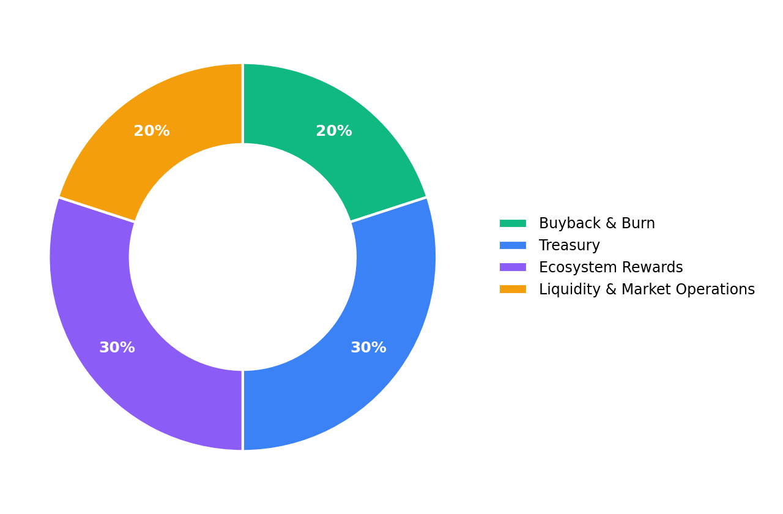

7. ICO Parameters
All sale figures are preliminary and may change.
Parameter | Value
Public Sale Price | $0.020 per TCA
Public Sale Amount | 180,000,000 TCA
Soft Cap | $1,500,000
Hard Cap | $3,600,000
Circulating at TGE | ~150,000,000 TCA (15%)
Initial Market Cap | ~$3,000,000
Fully Diluted Valuation (FDV) | $20,000,000

8. Use of Funds
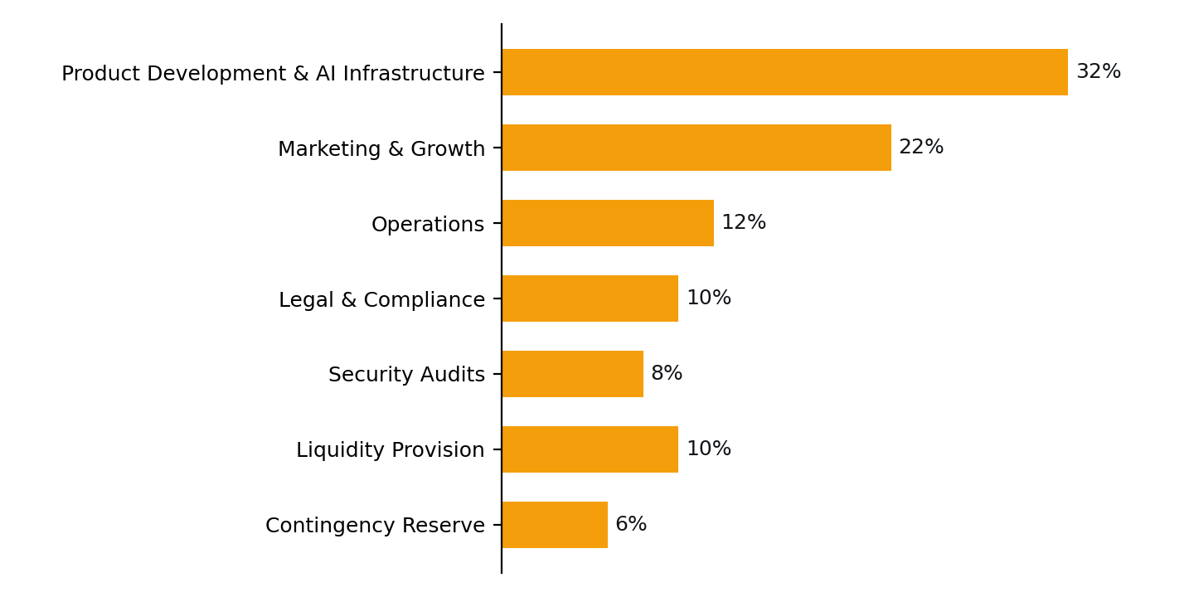
Category | Share
Product Development & AI Infrastructure | 32%
Marketing & Growth | 22%
Operations | 12%
Legal & Compliance | 10%
Security Audits | 8%
Liquidity Provision | 10%
Contingency Reserve | 6%

9. Roadmap

Q2 2026
- Concept & token design
- Whitepaper & legal review
- Landing page & waitlist

Q3 2026
- MVP launch
- AI services database (beta)
- Comparison engine (alpha)
- Team scaling
- Smart contract development

Q4 2026
- Contract audit & deploy
- ICO & TGE
- Staking v1
- Rewards distribution begins

Q1 2027
- AI agents marketplace (beta)
- Premium access via TCA
- Rewards & curation
- SMB onboarding

Q2 2027
- B2B / API layer
- Enterprise dashboard
- Workflow templates
- Partnerships

Q3–Q4 2027
- Multichain launch
- Governance expansion
- Advanced reputation
- Regional growth

10. Go-to-Market
Phase 1 (B2C): organic growth via SEO, AI tool comparisons, content, creator partnerships and referrals. Phase 2 (SMB): paid plans, ready playbooks, workflows and lead generation for vendors. Phase 3 (B2B / API): routing APIs, enterprise integrations, white-label modules and benchmarking products.

11. Team & Advisors
The core team covers product strategy, platform engineering, AI integration, smart-contract development, growth & partnerships, and legal & compliance. Advisors and an advisory board will be disclosed in stages around TGE and fundraising. (Profiles to be added.)

12. Risks
- Regulatory uncertainty
- Crypto market volatility
- Smart-contract risk
- Competition
- Dependence on third-party AI providers
- Execution risk
- Adoption speed
Participants acknowledge that token value may fluctuate and that TCA's utility does not guarantee returns.

13. Conclusion
TECHAGENT aims to become the trusted entry point into the AI economy. By combining discovery, comparison, reputation and an aligned utility token, the project helps people and businesses move from confusion to confident action. TCA exists to power real platform functions — not as a promise of speculative profit.

Appendix A. Allocation
Category | Share | Tokens
Public Sale / ICO | 18% | 180,000,000
Ecosystem & Rewards | 22% | 220,000,000
Treasury / Reserve | 15% | 150,000,000
Team | 15% | 150,000,000
Strategic Partners | 8% | 80,000,000
Advisors | 4% | 40,000,000
Marketing & Community | 10% | 100,000,000
Liquidity / Market Making | 8% | 80,000,000

Appendix B. Vesting
Category | At TGE | Cliff | Unlock
Public Sale | 20% | — | Linear over 6 months
Team | 0% | 12 months | Linear over 24 months
Advisors | 0% | 6 months | Linear over 12 months
Strategic Partners | 0% | 3 months | Linear over 12 months
Marketing & Community | Partial | — | 24 months
Ecosystem & Rewards | Partial | — | 48 months (KPI-based)
Treasury | By governance | N/A | Unlocked by vote

Appendix C. Key Metrics
Metric | Value
Total supply | 1,000,000,000 TCA
Public Sale Price | $0.020 per TCA
Public Sale Amount | 180,000,000 TCA
Soft Cap | $1,500,000
Hard Cap | $3,600,000
Circulating at TGE | ~150,000,000 TCA (15%)
Initial Market Cap | ~$3,000,000
Fully Diluted Valuation (FDV) | $20,000,000

Contacts
- Website: techagent.com
- Email: info@techagent.com
- Contract (Base): 0x0F81294C2549D1CabAc3ecBbd0d21e2d073F2309
- BaseScan: https://basescan.org/token/0x0F81294C2549D1CabAc3ecBbd0d21e2d073F2309

